AUTHOR STATEMENT
Title of the article:

Author(s):

Name of the author responsible for correspondence with the Publisher:
Address:

Tel/Fax: +62 856 9026 035 / -
E-mail: linny. luciana@ukrida.ac. id

The author(s) hereby confirm(s) that:
- The above-mentioned work has not previously been published and that it has not been submitted to the Publishers of any other journal (with the exception of abstracts not exceeding 250 words);
- All the co-authors named and the relevant authorities of the scientific institutions in which the work has been carried out are familiar with the contents of this work and have agreed to its publication;
- When sending the manuscript together with illustrations, tables and videos the authors agree to the automatic and free transfer of copyright to the Publisher allowing for the publication and distribution of the material submitted in all available forms and fields of exploitation, without limits of territory or language, provided that the material is accepted for publication. At the same time the authors accept that the submitted work will not be published elsewhere and in whatever language without the earlier written permission of the copyright holder, i.e. the Publisher;
- The authors empower the Publisher to make any necessary editorial changes to the submitted manuscript;
- The manuscript has been prepared in accordance with the Publisher's requirements;
- The authors are familiar with the regulations governing the acceptance of works as published in ‘CLINICAL DIABETOLOGY’ and agree to follow them;
- Protocol of the study was approved by the local Human Investigation Committee (or respective body) and subjects involved in the study signed informed consent approved by the institution (if relevant).
- The authors report any potential conflict of interest, which might include: grants funding the project; speaker honoraria from a company; consulting fees and stock options, other form of gratification.
No. | Author’s name | Conflict of interest declaration | Nature and level of contribution to the article
1. | Linny Luciana | No conflict of interest | Conceptualisation. methodology, srrpervision, interpretation. manuscript revision.
2. | Vebriona Angellee | No conflict of interest | Data collection, data curation, literature review draftinq.
3. | Tonny Loho | No conflict of interest | Clinical interpretation, methodological input, critical revision.
4. | Deviana | No conflict of interest | Data interpretation, literature review, manuscript revision.
5. | Harny Edward | No conflict of interest | Clinical interpretation, supervision, critical review
6.
7.
8.
9.
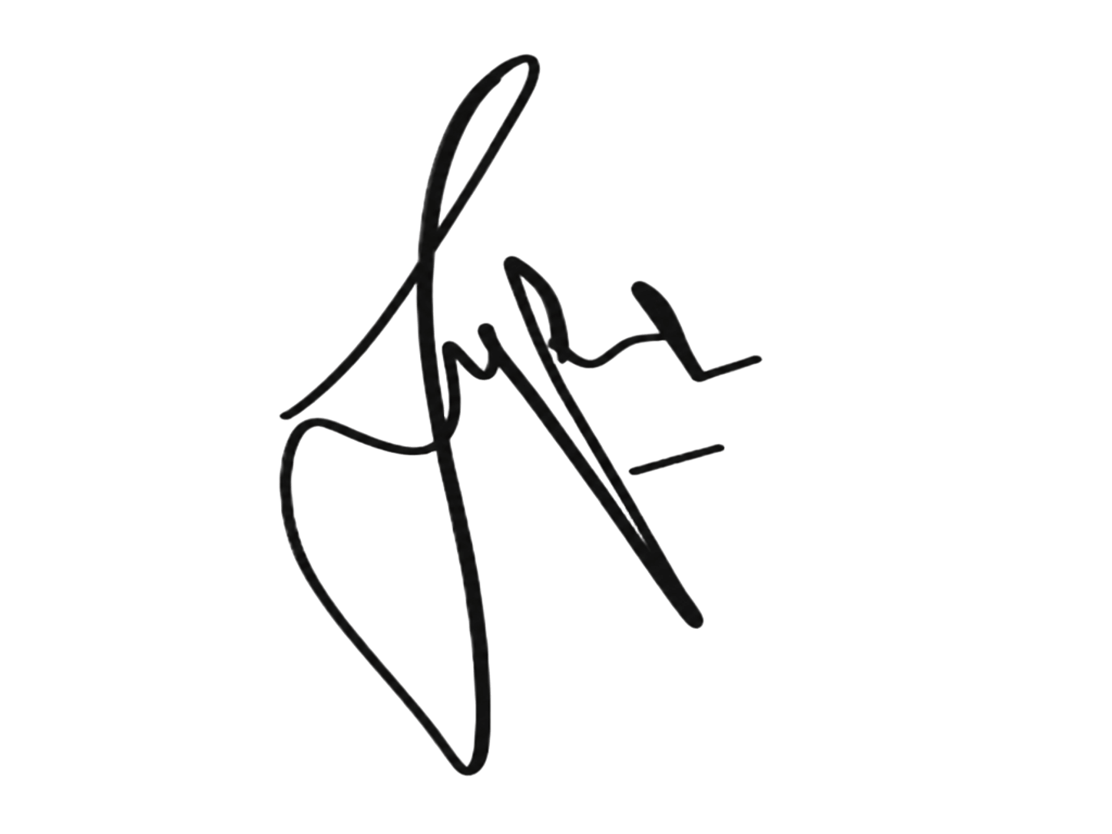
Date Signature of the author who obtained
the consent of the co-authors (if any): __________________________ (Linny Luciana)

